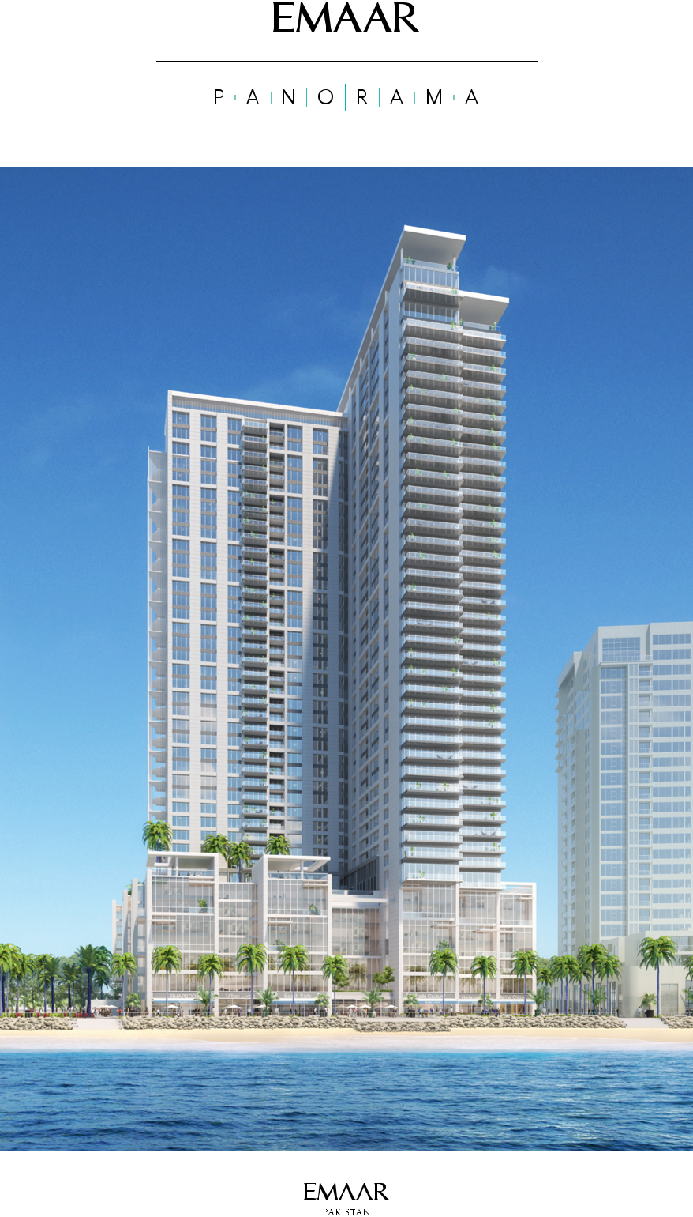



OPTION AGREEMENT

PERSONAL DETAILS:

First Name: ____________________________________________ Last Name: ____________________________________________

Nationality: ____________________________________________ Source: **EMKAY CONSULTANTS (M. MOEEN QURESHI)**

(for individuals)

NTN Number: _________________________________________ CNIC/NICOP No: _____________________________________

(Pakistan residents only)

Commercial Registration No: ______________________________ Date: _________________________________________________

(for non-individuals)

Place of Registration: ____________________________________

Address for Communication: (Please give complete details, including Tel / email)

For communication by Registered Post & Courier:

____________________________________________________________________________________________________________________

____________________________________________________________________________________________________________________

|  |  |  |  |
| --- | --- | --- | --- |
| City: _________________________________________________ | | Country: ______________________________________________ | |
| Phone: _______________________________________________ | | Mobile: _______________________________________________ | |
| email: ________________________________________________ | |  |  |
| Property Details: |  |  |  |
| 1-bedroom apartment | 2-bedroom apartment | 3-bedroom apartment | 4-bedroom apartment |

WHEREAS

1. The Grantor intends to develop a residential [and commercial] project known as ‘Panorama’ (Project) on land situated in Phase VIII-Extension of the Defence Housing Authority, Karachi (DHA) for which the DHA has already granted the Grantor a long term lease.

The Grantor proposes to launch the Project this year at which time it will enter into the necessary agreements with its customers.

1. The Optionee wishes to have a first option to enter into an agreement to purchase leasehold rights in an apartment unit in the

Project on its launch on the terms and conditions set out herein;

Signature _____________________________________ Signature _____________________________________

(For and on behalf of the Grantor) (By the Optionee)



2



NOW, THEREFORE, the parties hereto agree as follows:

1. Grant of Option

In consideration of the sum of Rupees Five Hundred Thousand (Rs.500,000) (Option Fee) paid by the Optionee to the Grantor on execution hereof, the Grantor hereby grants to the Optionee an option to enter into an agreement (Sale Agreement) to purchase leasehold rights from the Grantor in respect of one apartment unit (Unit) in the Project from such apartments units in the Project as are available at the time the Optionee exercises its option (Option). The Option Fee is non refundable and will be forfeited in the event the Optionee fails to exercise the Option in terms hereof. Subject to the terms and conditions hereof, during the Option Period

(defined in Clause 2 below) the Optionee’s right to enter into a Sale

Agreement and to select the Unit of the Optionee’s choice shall be in priority to other customers of the Grantor to whom similar Options have not been granted but shall, as amongst other option holders rank in order of priority which order of priority shall be based on the order in which the option agreements are executed and recorded in a register of the same maintained with the

Grantor which order cannot be challenged by any one including the Optionee.

1. Option Notice

2.1 The Option shall be exercisable by the Optionee within the option period (Option Period) notified by the Grantor to the Optionee (Option Notice). The Optionee may during the Option Period indicate its intention to exercise the Option within such notice period (Notice Period) as is specified in the Option Notice and after it has done so, the Grantor shall advise the Optionee of the Units available and the Optionee may proceed to exercise the Option in the manner provided in the Option Notice but no right to any Unit shall be created until and unless the Sale Agreement relating to that Unit is duly executed within the Option Period and all rights in the Unit shall be in terms of the Sale Agreement.

2.2 Nothing in this Agreement shall oblige the Grantor to procure that the Project is launched by any date or at all or that any Unit or any rights in any Unit will be available to any Optionee.

2.3 In the event the Grantor does not give the Option Notice to the Optionee by [______________] this Agreement shall terminate

without liability of any party to the other but the Option Fee shall be refunded to the Optionee without interest or mark-up whereupon the Optionee shall have no claim, demand or cause of action against the Grantor.

2.4 No assurance is given that any particular Unit will be available except that if the Option is properly exercised, then the Option Fee shall be credited against the sale price.

2.5 If the Optionee elects to not exercise this Option or violates in any manner the terms and conditions of this Agreement, the Option shall automatically and without notice from the Grantor expire on [the close of business day of] the Notice Period expiry date notified by the Grantor in the Option Notice. Without prejudice to the rights of the Grantor herein, the Grantor shall, at its sole and exclusive discretion, have the right but not the obligation to refund all or any part of the Option Fee to the Optionee in the event the Grantor in its sole and exclusive discretion considers the circumstances appropriate

1. Warranties

The Grantor makes no representations or warranties under this Agreement with regard to the Project, any Unit or the availability of any Unit of the choice of the Optionee except that in the event an Option Notice is issued then subject to due and proper exercise of the Option as provided in the Option Notice and execution within the Option Period of the necessary agreement, a Unit in the Project will be available for purchase by the Option holder.

1. Governing Law

This Agreement shall be governed by and construed in accordance with the laws of Pakistan.

1. Assignment

The Optionee may not assign this Agreement or the option granted herein or any interest therein to any person without the prior written consent of the Grantor.

1. Recording of Option Agreement

The Optionee shall not record this Agreement nor shall have any legal interest in the real estate which is the subject of this Agreement. Moreover, it is hereby agreed, declared and understood by the Optionee that this Agreement confers on him no rights, interest and title whatsoever in any real estate which is the subject of this Agreement or otherwise contemplated by this Agreement.

1. Entire Agreement

This Agreement constitutes the entire agreement between the parties. No representations, warranties or promises pertaining to the Option have been made by, or shall be binding upon, any of the parties, except as expressly stated in this Agreement. No modification or amendment to this Agreement will be effective unless in writing and signed by both parties.

IN WITNESS WHEREOF, the parties have executed and delivered this Option Agreement the day and year first above written.

For and on behalf of the Grantor: By the Optionee:

Signature _____________________________________________ Signature _____________________________________________

Name ________________________________________________ Name ________________________________________________

Witness 1 _____________________________________________ Witness 1 _____________________________________________

Witness 2 _____________________________________________ Witness 2 _____________________________________________



3

